UNIT III
Operators and Control flow

Operators:
In python programming we have 7 types of operators. They are:
- Arithmetic operator
- Assignment operator
- Relational operator
- Logical operator
- Bit wise operator
- Membership operator
a)in
  - not in
- Identity operator
a)is
  - is not
1.Arithmetic operator:

Sl No: | Meaning | Symbol(operator) | Examples a=10,b=3
1. | Addition | + | Print(a+b)→13
2. | Subtraction | - | Print(a-b)→7
3. | Multiplication | * | Print(a*b)→30
4. | Division | / | Print(a/b)→ 3.333333333333333
5. | Floor Division | // | Print(a//b)→3(Integer Quotient)
6. | Modulo Division | % | Print(a%b)→1(Gives Remain)
7. | Exponentiation | ** | Print(a**b)→1000

#Program for arithmetic Operators
#aop.py a=int(input("Enter Value of a:")) b=int(input("Enter Value of b:")) print("sum({},{})={}".format(a,b,a+b)) print("sub({},{})={}".format(a,b,a-b)) print("mul({},{})={}".format(a,b,a*b)) print("div({},{})={}".format(a,b,a/b)) print("F.Div({},{})={}".format(a,b,a//b)) print("mod({},{})={}".format(a,b,a%b))
print("pow({},{})={}".format(a,b,a**b))

Output:
Enter Value of a:10 Enter Value of b:4 sum(10,4)=14 sub(10,4)=6 mul(10,4)=40 div(10,4)=2.5 F.Div(10,4)=2 mod(10,4)=2 pow(10,4)=10000
2. Assignment operator :

=, +=, -=, *=, /=, %=
a=20 b=30
a += b
print(a)

a -= b
print(a)

a *= b print(a)

a /= b
print(a)

a %= b print(a)

Output:

50

20

600
20.0
20.0

3. Relational Operator(Comparison Operator):

>, <, >=, <=, ==, !=
#Program for demonstrating Relational Operators
#rop.py
a=int(input("Enter First value:")) b=int(input("Enter Second value:")) print("{} > {} = {}".format(a,b,a>b))
print("{} < {} = {}".format(a,b,a<b))
print("{} == {} = {}".format(a,b,a==b)) print("{} != {} = {}".format(a,b,a!=b)) print("{} >= {} = {}".format(a,b,a>=b)) print("{} <= {} = {}".format(a,b,a<=b))

Output:
Enter First value:10
Enter Second value:4

10 > 4 = True
10 < 4 = False
10 == 4 = False
10 != 4 = True
10 >= 4 = True
10 <= 4 = False

4. Logical operator • and
- or
- not and:
RelExpr1 | RelExpr2 | RelExpr1 and RelExpr2
True | False | False
False | True | False
False | False | False
True | True | True

>>> (10>5) and (20>3)--------True
>>> (-10<-20) and (10>3)-------False
>>> (10<20) and (20>4) and (30>25)-----True
>>> (10>20) and (20>4) and (30>25)----False
>>> (10<20) and (20<4) and (30>25)----False
>>> True and True----------True
>>> True and False--------False
>>> False and True--------False >>> False and False---------False
Or:
RelExpr1 | RelExpr2 | RelExpr1 or RelExpr2
True | False | True
False | True | True
False | False | False
True | True | True

>>> (10<2) or (20>5)-------True
>>> (10>2) or (20<5)------True
>>> (10>2) or (34>45) or (56>7)---True
>>> (10<2) or (34>45) or (56<7)------False
>>> (10<2) or (34>45) or (56>7)----True
>>> True or True----------------True
>>> False or True--------------True
>>> False or False-------------False
>>> True or False-------------True

Not:
RelExpr1 | not RelExpr1
True | False
False | True

>>> not True------------False
>>> not False---------True
>>> (10>2)-------------True
>>> not (10>2)--------False
>>> (10>2) and (20>5)------True
>>> not ((10>2) and (20>5))-------False
>>> (10<2) or (20<5)----------False
>>> not ((10<2) or (20<5))-------True

5. Bit wise operator
• In Python Programming, we have 6 Bitwise Operators. They are
- Bitwise Left Shift Operator ( << )
- Bitwise Right Shift Operator ( >> )
- Bitwise OR Operator ( | )
- Bitwise AND Operator ( & )
- Bitwise Complement Operator ( ~ )
- BitWise XOR Operator ( ^ )

#Program for swapping of two numerical values
#SwapXOR.py
a=int(input("Enter value of a:")) b=int(input("Enter value of b:")) print("Original Value of a:{}".format(a)) print("Original Value of b:{}".format(b)) #Swapping Logic By using BitWise XOR ( ^ ) a=a^b b=a^b a=a^b print("Swapped Value of a:{}".format(a))
print("Swapped Value of b:{}".format(b))

Output:
Enter value of a:10
Enter value of b:4
Original Value of a:10
Original Value of b:4
Swapped Value of a:4
Swapped Value of b:10

6. Membership operator
a)in
b) not in

>>> s="PYTHON"
>>> print(s)------PYTHON
>>> "P" in s------True
>>> "P" not in s-------False
>>> "N" not in s-------False
>>> "N" in s------------True
>>> "n" in s------------False
>>> "n" not in s--------True
>>> s="PYTHON"
>>> print(s)--------PYTHON
>>> "PYTH" in s--------True >>> "THON" in s-------True
>>> "HON" in s---------True
>>> "PTH" in s----------False
>>> "PTO" not in s-----True
>>> "PTO" in s-----------False
>>> "NOH" in s----------False
>>> "NOH" not in s-----True
>>> "NOHT" not in s------True

7. Identity operator
a)is
b) is not
>>>s1="Rossum"
>>> s2="Rossum"
>>> print(s1,id(s1))----------Rossum 2636962954800
>>> print(s2,id(s2))----------Rossum 2636962954800
>>> s1 is s2-----------------True
>>> s1 is not s2-----------False
>>> s1="Ram"
>>> s2="ram"
>>> s1 is s2----------False
>>> s1 is not s2---------True

CONTROL FLOW

1) Conditional Statements
- Conditional if
- Alternative if… else
- Chained if…elif…else
- Nested if….else

Conditional (if):
conditional (if) is used to test a condition, if the condition is true the statements inside if will be
executed. syntax:

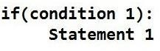

Flowchart:
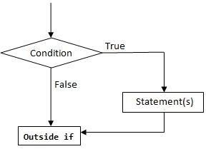

Program to provide bonus mark if the category is |  | output
Sports
m=eval(input(“enter ur mark out of 100”)) |  | enter ur mark out of 100
c=input(“enter ur categery G/S”) |  | 85
if(c==”S”): |  | enter ur categery G/S
m=m+5 |  | S
print(“mark is”,m) |  | mark is 90

Alternative (if-else):
In the alternative the condition must be true or false. In this else statement can be combined with if statement. The else statement contains the block of code that executes when the condition is false. If the condition is true statements inside the if get executed otherwise else part gets executed. The alternatives are called branches, because they are branches in the flow of execution.

syntax:
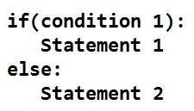
Flowchart:
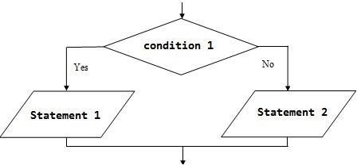

Examples:
- odd or even number
- positive or negative number
- leap year or not

Odd or even number |  | Output
n=eval(input("enter a number")) if(n%2==0):  print("even number") else:  print("odd number") |  | enter a number4 even number
positive or negative number |  | Output
n=eval(input("enter a number")) if(n>=0):  print("positive number")  else:  print("negative number") |  | enter a number8 positive number
leap year or not |  | Output
y=eval(input("enter a year")) if(y%4==0):  print("leap year")  else:  print("not leap year") |  | enter a year2000 leap year
Chained conditionals (if-elif-else)

  - The elif is short for else if.
  - This is used to check more than one condition.

  - If condition1 is False, it checks the condition2 of the elif block. If all the conditions are False, then the else part is executed.

  - Among the several if...elif...else part, only one part is executed according to the condition.

The if block can have only one else block. But it can have multiple elif blocks.

▪ The way to express a computation like that is a chained conditional.
syntax:

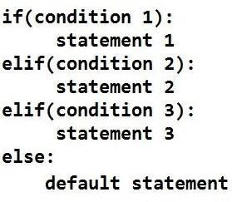

Flowchart:

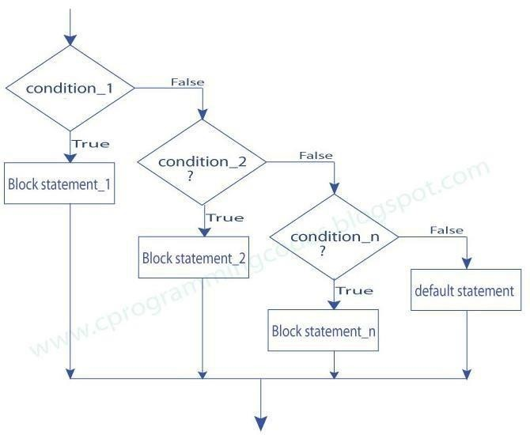

Example:
- student mark system
- traffic light system

student mark system |  | Output
mark=eval(input("enter ur mark:")) if(mark>=90): print("grade:S")  elif(mark>=80): print("grade:A")  elif(mark>=70):  print("grade:B")  elif(mark>=50):  print("grade:C")  else:  print("fail") |  | enter ur mark:78 grade:B
traffic light system |  | Output
colour=input("enter colour of light:") if(colour=="green"): print("GO")  elif(colour=="yellow"):  print("GET READY") else:  print("STOP") |  | enter colour of light:green  GO

Nested conditionals
One conditional can also be nested within another. Any number of condition can be nested inside one another. In this, if the condition is true it checks another if condition1. If both the conditions are true statement1 get executed otherwise statement2 get execute. if the condition is false statement3 gets executed

Syntax

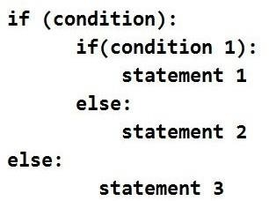
Flowchart:
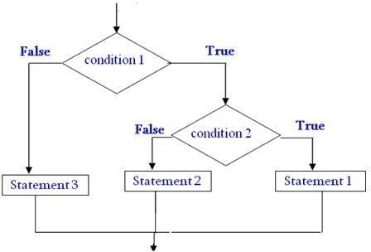
Example:
- greatest of three numbers
- positive negative or zero
greatest of three numbers | output
  a=eval(input(“enter  the  value  of  a”))  b=eval(input(“enter  the  value  of  b”))  c=eval(input(“enter  the  value  of  c”))  if(a>b):  if(a>c):  print(“the  greatest  no  is”,a)  else:      else: if(b>c):    print(“the greatest no is”,b) else:    print (“the greatest no is “,c) ))is”,c) |   enter the value of a 9  enter the  value of a 1  enter  the  value  of  a  8  the  greatest  no  is  9

positive

negative

or

zero

n=eval(input("enter

the

value

of

n:"))

if(n==0):

print("the

number is zero")

else:

if(n>0):

print("the

number

is

positive")

else:

print("the

number

is

negative")

output

enter

the

value

of

n:
-
9

the

number

is

negative

2.Iteration Or Control Statements.
- State
- while
- for
- break
- continue
- pass
State:
Transition from one process to another process under specified condition with in a time is called
state.
While loop:
While loop statement in Python is used to repeatedly executes set of statement as long as a given condition is true.
In while loop, test expression is checked first. The body of the loop is entered only if the test expression is True. After one iteration, the test expression is checked again. This process continues until the test expression evaluates to False.
In Python, the body of the while loop is determined through indentation. The statements inside the while start with indentation and the first unintended line marks the end.

Syntax:
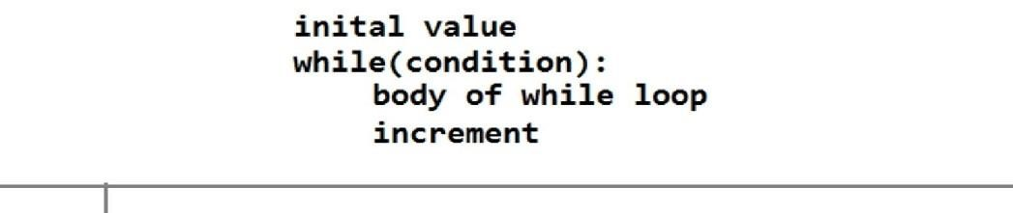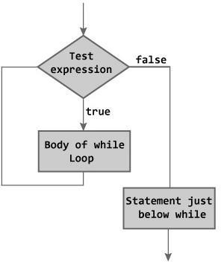

Flow

chart:

Examples:
- program to find sum of n numbers:
- program to find factorial of a number
- program to find sum of digits of a number:
- Program to Reverse the given number:
- Program to find number is Armstrong number or not
- Program to check the number is palindrome or not

Sum of n numbers: | output
n=eval(input("enter n")) | enter n
i=1 | 10
sum=0 while(i<=n): sum=sum+i i=i+1 print(sum) | 55
Factorial of a numbers: | output
n=eval(input("enter n")) i=1 fact=1 while(i<=n): fact=fact*i i=i+1 print(fact) | enter n 5  120
Sum of digits of a number: | output
n=eval(input("enter a number")) | enter a number
sum=0 while(n>0): a=n%10  sum=sum+a n=n//10  print(sum) | 123  6

Reverse the given number: | output
n=eval(input("enter a number"))  sum=0 while(n>0): a=n%10 sum=sum*10+a n=n//10 print(sum) | enter a number  123  321
Armstrong number or not | output
n=eval(input("enter a number")) org=n sum=0 while(n>0): a=n%10 sum=sum+a*a*a  n=n//10  if(sum==org):  print("The given number is Armstrong  number") else:  print("The given number is not  Armstrong number") | enter a number153  The given number is Armstrong number
Palindrome or not | output
n=eval(input("enter a number")) enter a number121
org=n The given no is palindrome sum=0 while(n>0): a=n%10 sum=sum*10+a n=n//10
if(sum==org):
print("The given no is palindrome")
else:
print("The given no is not palindrome")
For loop:
for in range:
We can generate a sequence of numbers using range() function. range(10) will generate numbers from 0 to 9 (10 numbers).
In range function have to define the start, stop and step size as range(start,stop,step size). step size defaults to 1 if not provided.

syntax

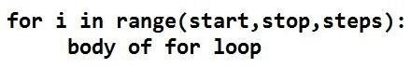

Flowchart:

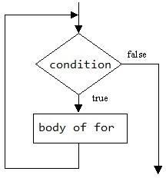

For in sequence
- The for loop in Python is used to iterate over a sequence (list, tuple, string). Iterating over a sequence is called traversal. Loop continues until we reach the last element in the sequence.
- The body of for loop is separated from the rest of the code using indentation.

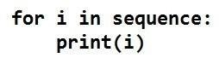

Sequence can be a list, strings or tuples

s.no | Sequences | example | output
1. | For loop in string | for i in "Ramu":  print(i) | R  A  M  U
2. | For loop in list | for i in [2,3,5,6,9]:  print(i) | 2  3  5  6  9
3. | For loop in tuple | for i in (2,3,1):  print(i) | 2  3  1
Examples:
- Program to print Fibonacci series.
- check the no is prime or not
Fibonacci

series

output

a=0 | Enter the number of terms: 6
b=1 | Fibonacci Series:
n=eval(input("Enter the number of terms: ")) | 0 1
print("Fibonacci Series: ") | 1
print(a,b) | 2
for i in range(1,n,1): | 3
c=a+b | 5
print(c) a=b | 8
b=c

check

the

no

is

prime

or

not

output

n=eval(input("enter

a

number"))

enter

a

no:7

for

i

in

range(2,n):

if(n%i==0):

print("The

num

is

not

a

prime")

break

else:

print("The

num

is

a

prime

number.")

The

num

is

a

prime

number.

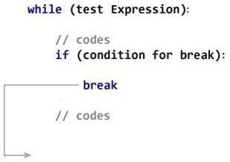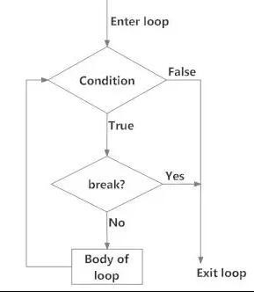
3.

Loop

Control

Structures

BREAK

•

Break

statements

can

alter

the

flow

of

a

loop.

•

It

terminates

the

current

•

loop

and

executes

the

remaining

statement

outside

the

loop.

•

If

the

loop

has

else

statement,

that

will

also

gets

terminated

and

come

out

of

the

loop

completely.

Syntax:

break

Flowchart

Example

Output

for

i

in

"welcome":

if(i=="c"):

break

print(i)

w

e

l

CONTINUE
It terminates the current iteration and transfer the control to the next iteration in the loop.
Syntax: Continue
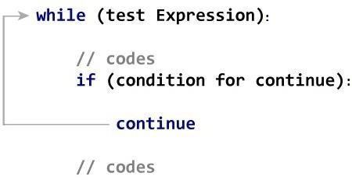
Flowchart
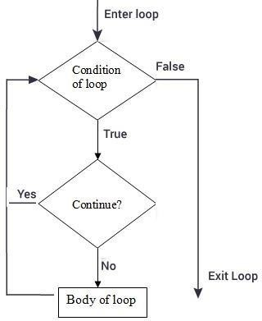

 | Example: |  | Output
 | for i in "welcome":  if(i=="c"): continue print(i) |  | w e  l  o  m  e
 |  | PASS
- It is used when a statement is required syntactically but you don’t want any code to execute.
- It is a null statement, nothing happens when it is executed.


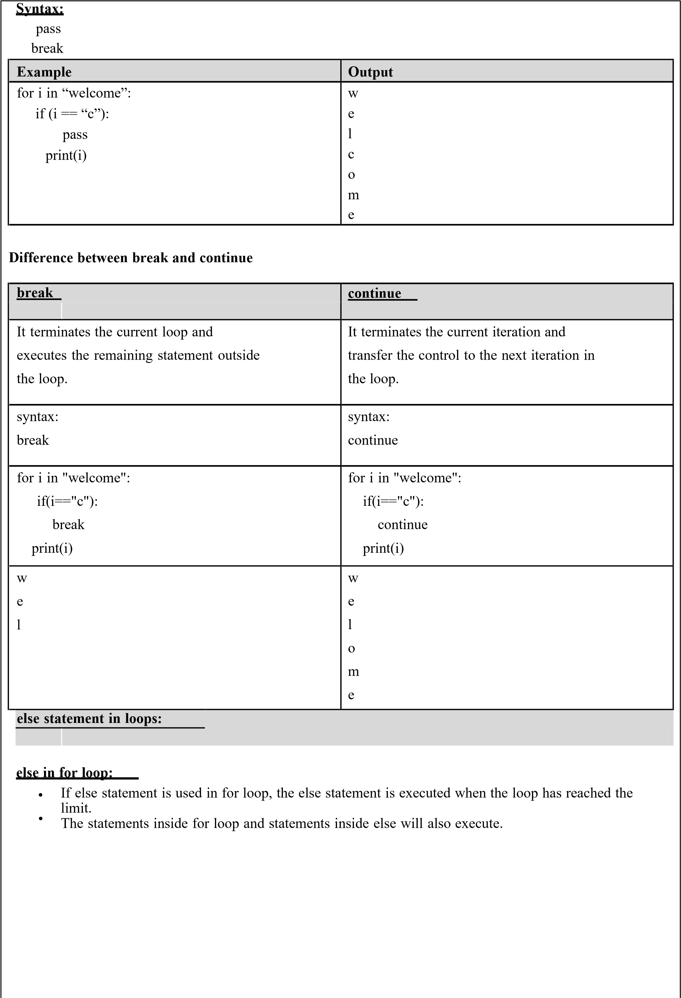
Example | output
for i in range(1,6): | 1
print(i) | 2
else: | 3
print("the number greater than 6") | 4  5 the number greater than 6

else in while loop:
If else statement is used within while loop , the else part will be executed when the condition become false.
The statements inside for loop and statements inside else will also execute.
Program | output
i=1 | 1
while(i<=5): | 2
print(i) | 3
i=i+1 | 4
else: | 5
print("the number greater than 5") | the number greater than 5

4) Explain about Strings and its operation:
String is defined as sequence of characters represented in quotation marks
(either single quotes ( ‘ ) or double quotes ( “ ).
An individual character in a string is accessed using a index.
The index should always be an integer (positive or negative).
A index starts from 0 to n-1.
Strings are immutable i.e. the contents of the string cannot be changed after it is created. Python will get the input at run time by default as a string.
Python does not support character data type. A string of size 1 can be treated as characters.
- single quotes (' ')
- double quotes (" ")
- triple quotes(“”” “”””)

Operations on string:
- Indexing
- Slicing
- Concatenation
- Repetitions
- Member ship

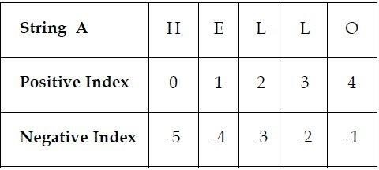
indexing | >>>a=”HELLO” | Positive indexing helps in accessing the string from the beginning  Negative subscript helps in accessing the string from the end.
indexing | >>>print(a[0])
indexing | >>>H
indexing | >>>print(a[-1])
indexing | >>>O
 | Print[0:4] – HELL | The Slice[start : stop] operator extracts
Slicing: | Print[ :3] – HEL  Print[0: ]- HELLO | sub string from the strings.  A segment of a string is called a slice.
Concatenation | a=”save” b=”earth”  >>>print(a+b)  Save earth | The + operator joins the text on both sides of the operator.
Repetitions: | a=”panimalar ” >>>print(3*a) panimalarpanimalar panimalar | The * operator repeats the string on the left hand side times the value on right

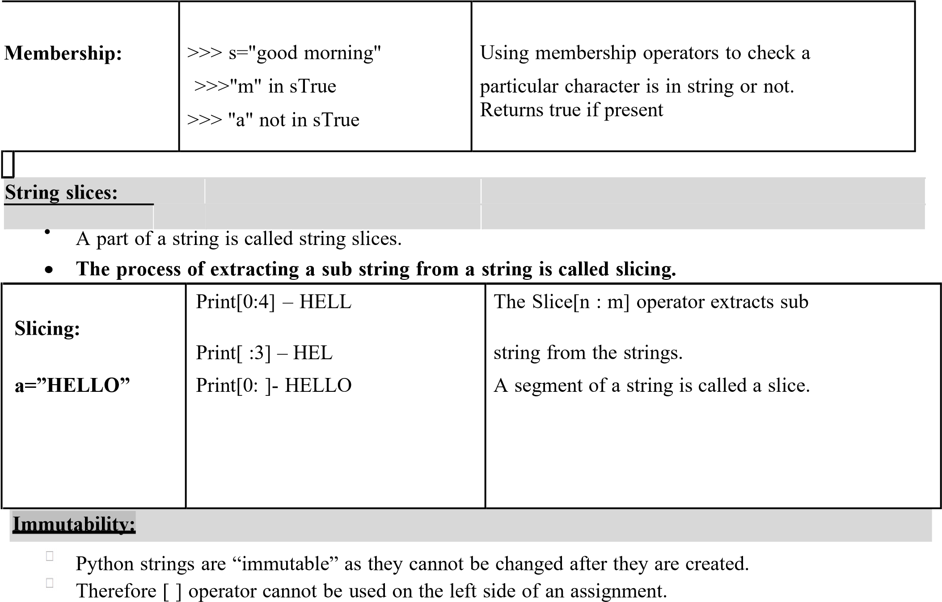

Operations | Example | output
element assignment | a="PYTHON"  a[0]='x' | TypeError: 'str' object does  not support element  assignment
element deletion | a=”PYTHON”  del a[0] | TypeError: 'str' object doesn't support element deletion
delete a string | a=”PYTHON”  del a print(a) | NameError: name 'my_string'  is not defined
string built in functions and methods:
A method is a function that “belongs to” an object.

Syntax to access the method
Stringname.method()
a=”happy birthday” here, a is the string name.
 | Syntax | example | description
1 | a.capitalize() | >>> a.capitalize()  ' Happy birthday’ | capitalize only the first letter in a string
2 | a.upper() | >>> a.upper()  'HAPPY BIRTHDAY’ | change string to upper case
3 | a.lower() | >>> a.lower()  ' happy birthday’ | change string to lower case
4 | a.title() | >>> a.title()  ' Happy Birthday ' | change string to title case i.e.  first characters of all the words are capitalized.
5 | a.swapcase() | >>> a.swapcase() 'HAPPY BIRTHDAY' | change lowercase characters to uppercase and vice versa
6 | a.split() | >>> a.split()  ['happy', 'birthday'] | returns a list of words separated by space
7 | a.center(width,”fillchar ”) | >>>a.center(19,”*”)  '***happy birthday***' | pads the string with the specified “fillchar” till length is equal to “width” | the
8 | a.count(substring) | >>> a.count('happy')  1 | returns the number  occurences of substring | of
9 | a.replace(old,new) | >>>a.replace('happy',  'wishyou happy') 'wishyou happy birthday' | replace all old substrings  with new substrings
10 | a.join(b) | >>> b="happy"  >>> a="-"  >>> a.join(b)  'h-a-p-p-y' | returns a string concatenated with the elements of an iterable. (Here “a” is the iterable)
11 | a.isupper() | >>> a.isupper()  False | checks whether all the case- based characters (letters) of the string are uppercase.
12 | a.islower() | >>> a.islower()  True | checks whether all the case- based characters (letters) of the string are lowercase.
13 | a.isalpha() | >>> a.isalpha()  False | checks whether the string consists of alphabetic characters only.
String modules:
- A module is a file containing Python definitions, functions, statements.
- Standard library of Python is extended as modules.
- To use these modules in a program, programmer needs to import the module.
- Once we import a module, we can reference or use to any of its functions or variables in our code.
- There is large number of standard modules also available in python.
- Standard modules can be imported the same way as we import our user-defined modules.
Syntax: import module_name
Example | output
import string  print(string.punctuation) | !"#$%&'()*+,-./:;<=>?@[\]^_`{|}~
print(string.digits) print(string.printable) print(string.capwords("happ | 0123456789  0123456789abcdefghijklmnopqrstuvwxyzABCDEFGHIJ  KLMNOPQRSTUVWXYZ!"#$%&'()*+,-
y birthday")) print(string.hexdigits)  print(string.octdigits) | ./:;<=>?@[\]^_`{|}~  Happy Birthday  0123456789abcdefABCDEF  01234567
Escape sequences in string
Escape Sequence | Description | example
\n | new line | >>> print("hai \nhello")  hai hello
\\ | prints Backslash (\) | >>> print("hai\\hello") hai\hello
\' | prints Single quote (') | >>> print("'")  '
\" | prints Double quote  (") | >>>print("\"")  "
\t | prints tab sapace | >>>print(“hai\thello”) hai hello
\a | ASCII Bell (BEL) | >>>print(“\a”)

5) Array:

Array is a collection of similar elements. Elements in the array can be accessed by index. Index starts with 0. Array can be handled in python by module named array.
To create array have to import array module in the program.
Syntax :
import array
Syntax to create array:
Array_name = module_name.function_name(‘datatype’,[elements]) example:
a=array.array(‘i’,[1,2,3,4]) a- array name array- module name i- integer datatype

Example
Program to find sum of |  | Output
array elements |  | Output
import array  sum=0  a=array.array('i',[1,2,3,4]) for i in a:  sum=sum+i print(sum) |  | 10

Convert list into array: fromlist() function is used to append list to array. Here the list is act like a array.
Syntax:
arrayname.fromlist(list_name)

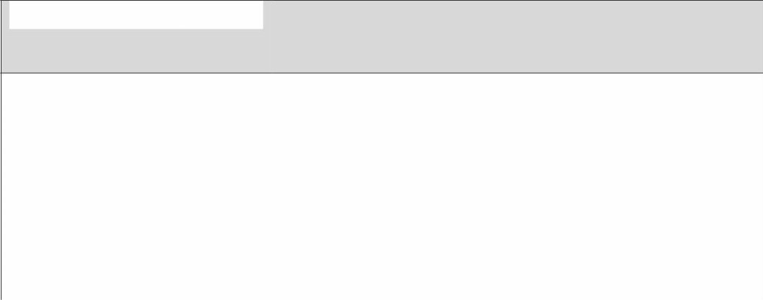
Example

program

to

convert

list

into

array

Output

import

array

sum=0

l=[6,7,8,9,5]

a=array.array('i',[])

a.fromlist(l)

for

i

in

a:

sum=sum+i

print(sum)

35

Methods of an array

a=[2,3,4,5]

 | Syntax | example | Description
1 | array(data type,  value list) | array(‘i’,[2,3,4,5]) | This function is used to create an array with data type and value list specified in its arguments.
2 | append() | >>>a.append(6) [2,3,4,5,6] | This method is used to add the at the end of the array.
3 | insert(index,element) | >>>a.insert(2,10)  [2,3,10,5,6] | This method is used to add the value at the position specified in its argument.
4 | pop(index) | >>>a.pop(1) [2,10,5,6] | This function removes the element  at the position  mentioned in its argument, and returns it.
5 | index(element) | >>>a.index(2) 0 | This function returns the index of value
6 | reverse() | >>>a.reverse() [6,5,10,2] | This function reverses the array.
7 | count() | a.count() | This is used to count number
Square root using newtons method: | Output:
def newtonsqrt(n): root=n/2 for i in range(10):  root=(root+n/root)/2  print(root)  n=eval(input("enter number to find Sqrt: ")) newtonsqrt(n) | enter number to find Sqrt: 9  3.0
GCD of two numbers | Output
n1=int(input("Enter a number1:")) n2=int(input("Enter a number2:")) for i in range(1,n1+1):  if(n1%i==0 and n2%i==0):  gcd=i  print(gcd) | Enter a number1:8  Enter a number2:24  8
Exponent of number | Output:
def power(base,exp):  if(exp==1):  return(base)  else:  return(base*power(base,exp-1)) base=int(input("Enter base: ")) exp=int(input("Enter exponential value:")) result=power(base,exp) print("Result:",result) | Enter base: 2  Enter exponential value:3  Result: 8
sum of array elements: | output:
a=[2,3,4,5,6,7,8] sum=0 for i in a:  sum=sum+i  print("the sum is",sum) | the sum is 35
Linear search | Output
a=[20,30,40,50,60,70,89]  print(a)  search=eval(input("enter a element to search:")) for i in range(0,len(a),1):  if(search==a[i]):  print("element found at",i+1) break  else:  print("not found") | [20, 30, 40, 50, 60, 70, 89] enter a element to search:30 element found at 2
7. ILLUSTRATIVE PROGRAMS:

Binary search | Output
a=[20, 30, 40, 50, 60, 70, 89] | [20, 30, 40, 50, 60, 70, 89]
print(a) search=eval(input("enter a element to search:")) start=0 stop=len(a)-1 while(start<=stop): mid=(start+stop)//2 if(search==a[mid]):  print("element found at",mid+1) break  elif(search<a[mid]):  stop=mid-1 else: start=mid+1 else:  print("not found") | enter a element to search:30 element found at 2

Two marks:
1. What is the Boolean value?
- Boolean data type have two values. They are 0 and 1.
- 0 represents False
- 1 represents True
Example:

>>>

3==5

False

>>>

6==6

True

>>>

True+True

2

>>>

False+True

1

>>>

False*True

0

•

True

and

False

are

keyword.

2.

Difference

between

break

and

continue.

Break |  | Continue
It terminates the current loop and executes the remaining statement outside the loop. | It terminates the current iteration and transfer the control to the next iteration in the loop.
syntax: break | syntax: continue
for i in "welcome":  if(i=="c"): break print(i) | for i in "welcome": if(i=="c"):  continue print(i)
w e l | w e l o m e
- Write a Python program to accept two numbers, multiply them and print the result.

number1 = int(input("Enter first number: ")) number2 = int(input("Enter second number: "))
mul = number1 * number2
print("Multiplication of given two numbers is: ", mul)

- Write a Python program to accept two numbers, find the greatest and print the result. number1 = int(input("Enter first number: ")) number2 = int(input("Enter second number: ")) if(number1>number2):
print('number1 is greater',number1) else:
print('number2 is greater',number2)

- Define recursive function.
Recursion is a way of programming or coding a problem, in which a function calls itself one
or more times in its body. Usually, it is returning the return value of this function call. If a function definition fulfils the condition of recursion, we call this function a recursive function.

Example:

def factorial(n): if n == 1:
return 1
else:
return n * factorial(n-1)

- Write a program to find sum of n numbers:

n=eval(input("enter n")) enter n i=1 10 sum=0 55 while(i<=n): sum=sum+i i=i+1 print(sum)

- What is the purpose of pass statement?
Using a pass statement is an explicit way of telling the interpreter to do nothing.
- It is used when a statement is required syntactically but you don’t want any code to execute.
- It is a null statement, nothing happens when it is executed.

Syntax: pass
break
Example | Output
for i in “welcome”:  if (i == “c”): pass  print(i) | w  e  l  c o  m  e

- Compare string and string slices.
A string is a sequence of character.
Eg: fruit = ‘banana’ String Slices :
A segment of a string is called string slice, selecting a slice is similar to selecting a character. Eg: >>> s ='Monty Python'
>>> print s[0:5] Monty
>>> print s[6:12] Python

- Explain global and local scope.
The scope of a variable refers to the places that we can see or access a variable. If we define a variable on the top of the script or module, the variable is called global variable. The variables that are defined inside a class or function is called local variable.
Eg:
def my_local():
a=10
print(“This is local variable”) Eg: a=10 def my_global():
print(“This is global variable”)

10. Mention a few string functions.
s.captilize() – Capitalizes first character of string
s.count(sub) – Count number of occurrences of string
s.lower() – converts a string to lower case
s.split() – returns a list of words in string

